Nama : Fahmi Ali

Jurusan : D3 MANAJEMEN INFORMATIKA

1. Start your eclipse lalu brows your workspace dan klik launch

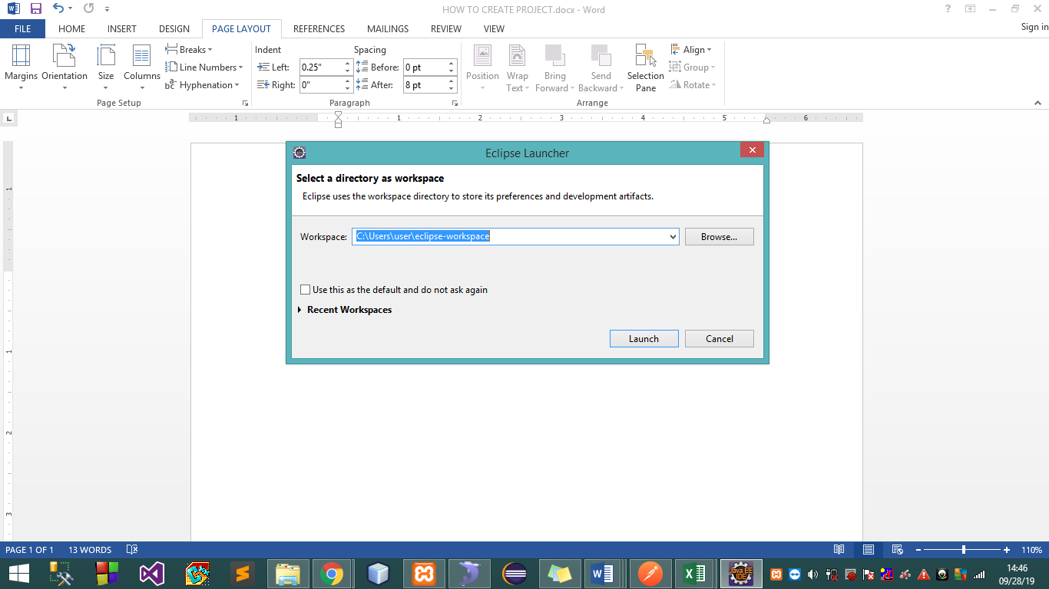

1. Choose file>new>other

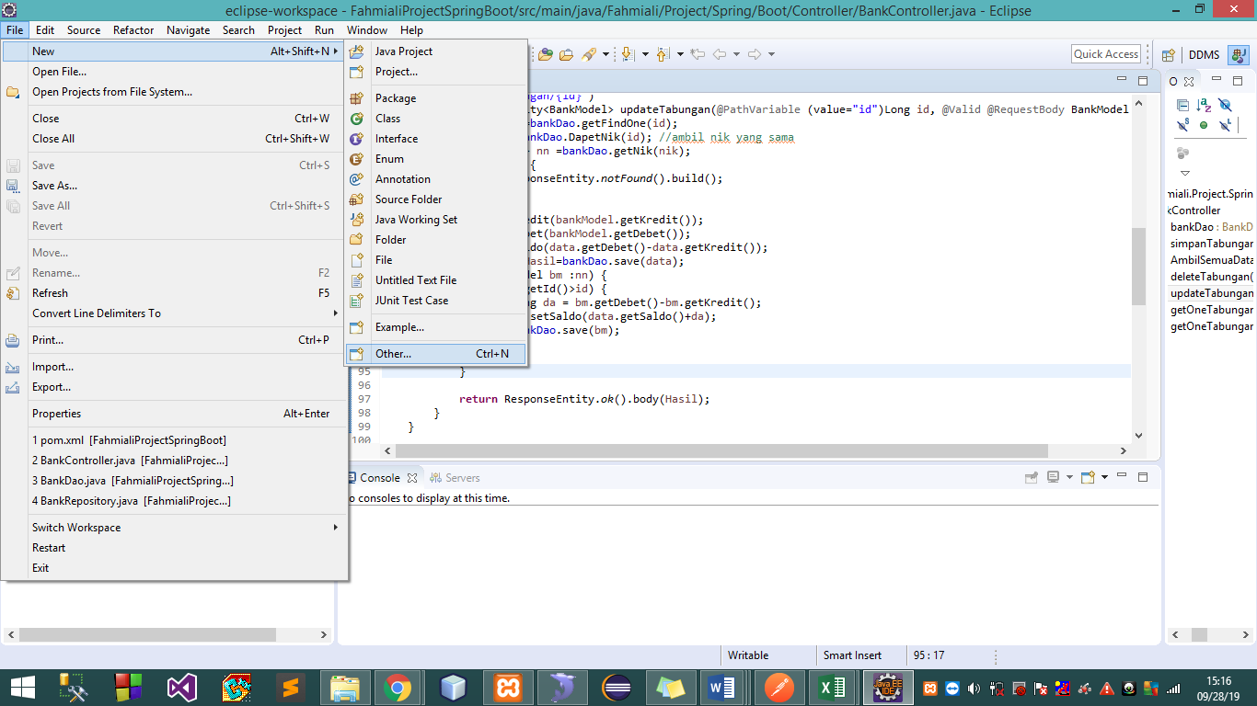

1. Choose maven>maven project>next

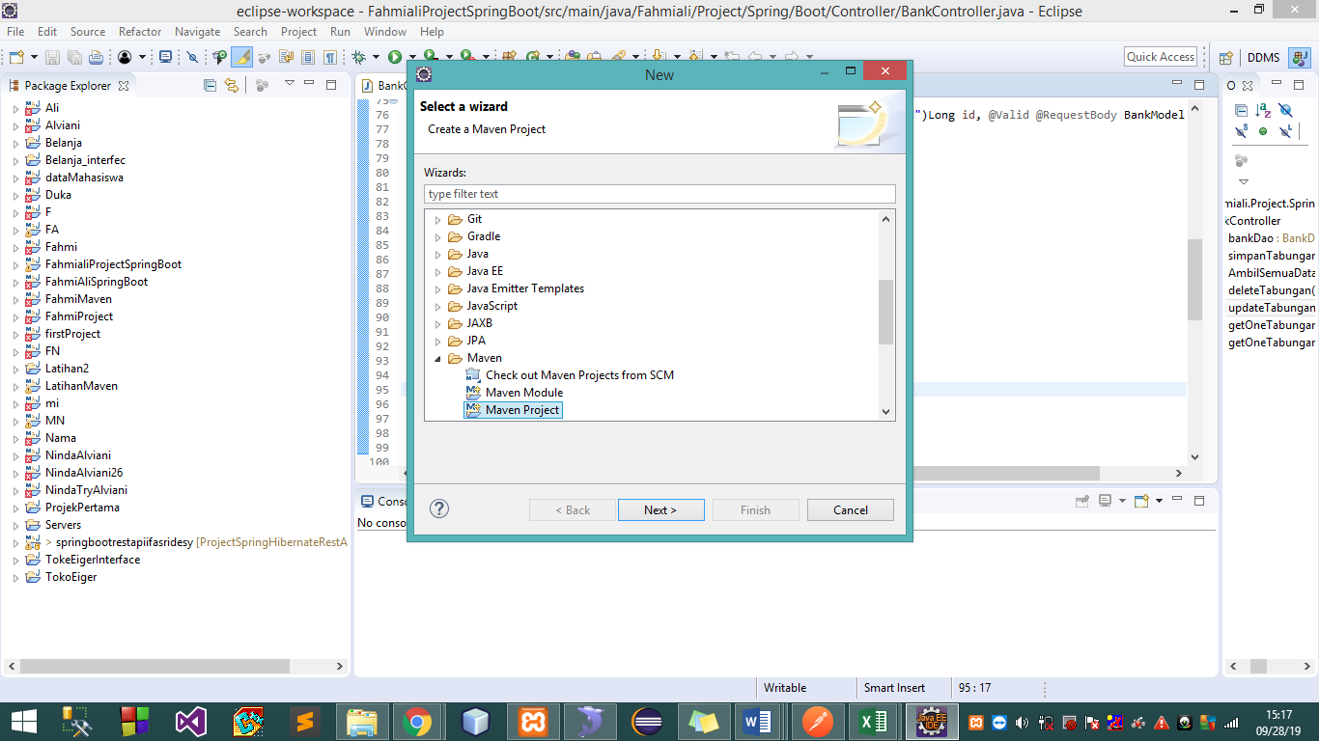

1. Select your directory>next

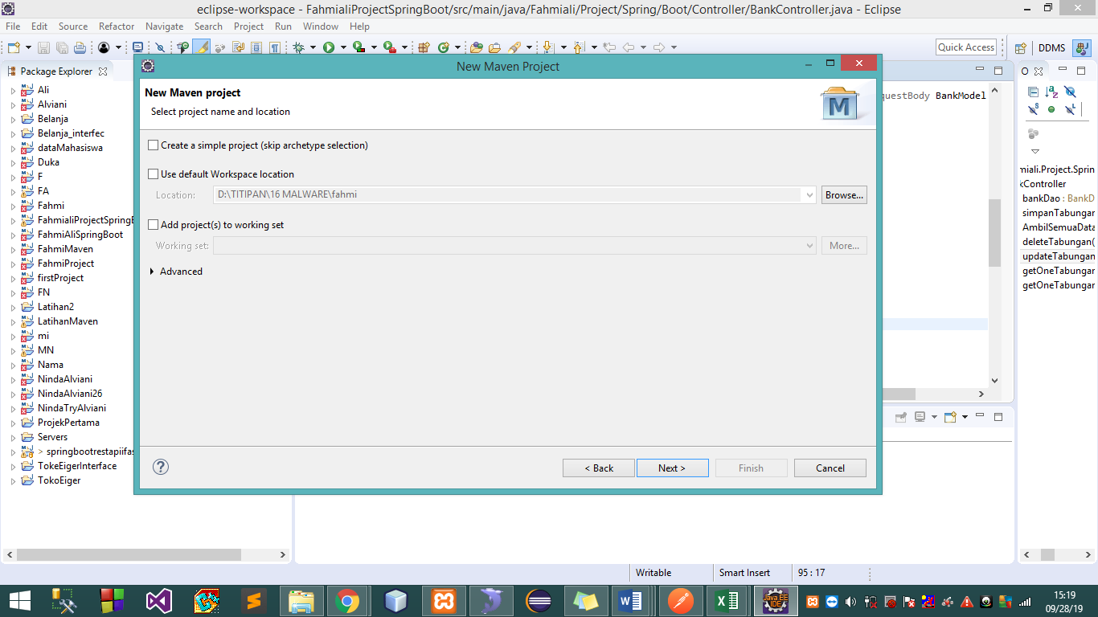

1. Select maven-archetype-webapp

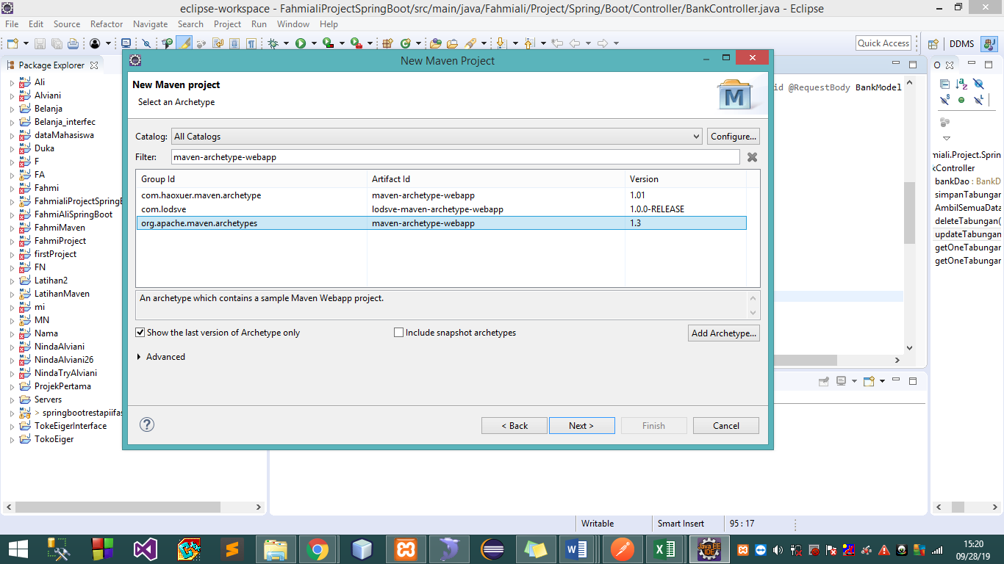

1. Fill the group id and artefact id then finish

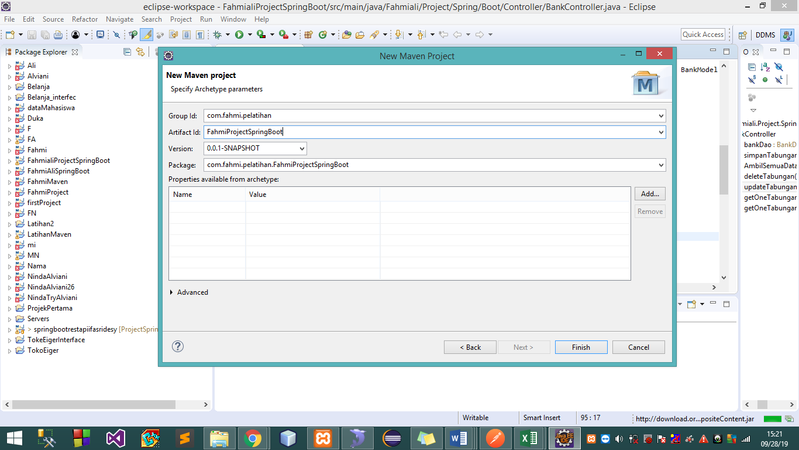

1. Choose pom.xml> tab pom.xml

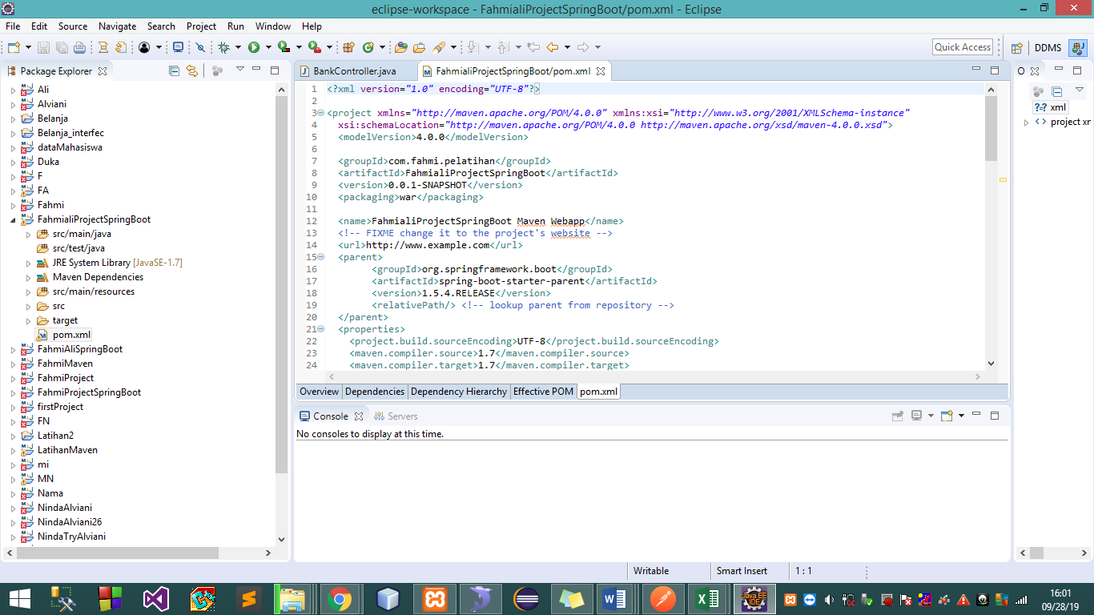

1. Click right on project ***FahmialiProjectSpringBoot>properties***

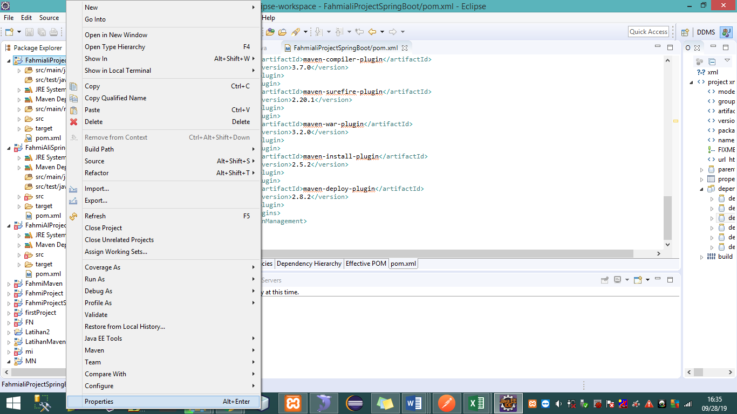

1. Choose java build path, checked all, then apply and close

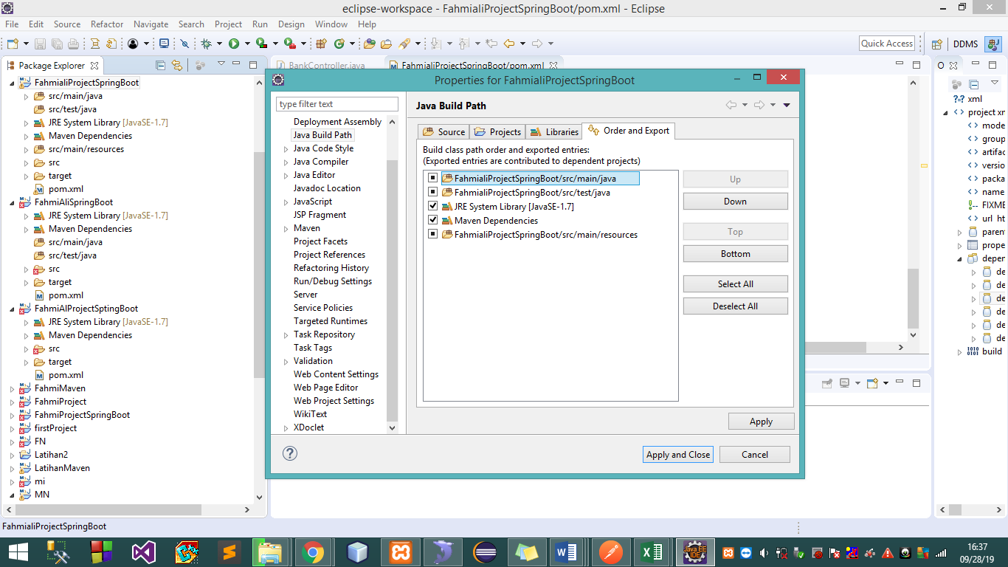

1. Open pom.xml>tab pom.xml

Add dependency on dependencies

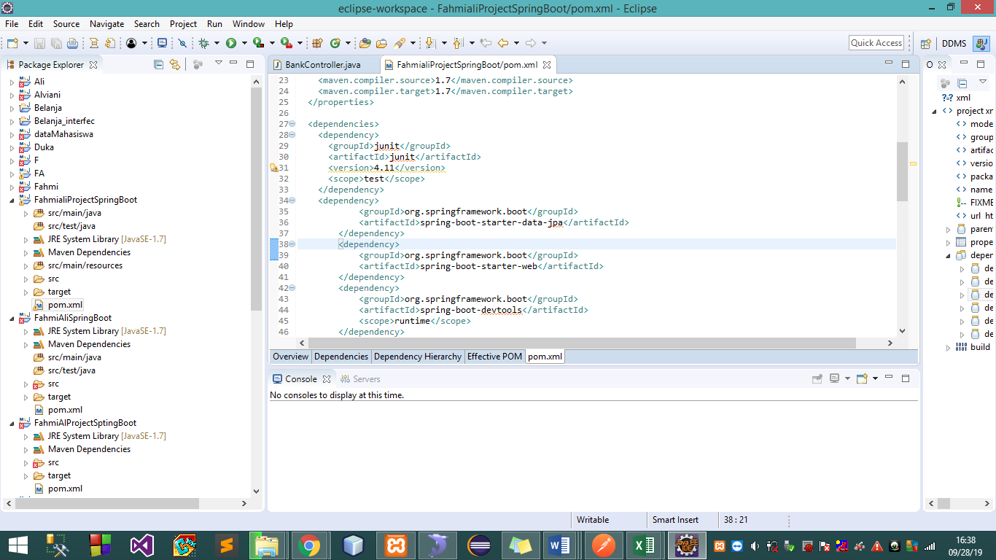

1. Click right on java/main/resource choose new>file and give name application.propertise finish

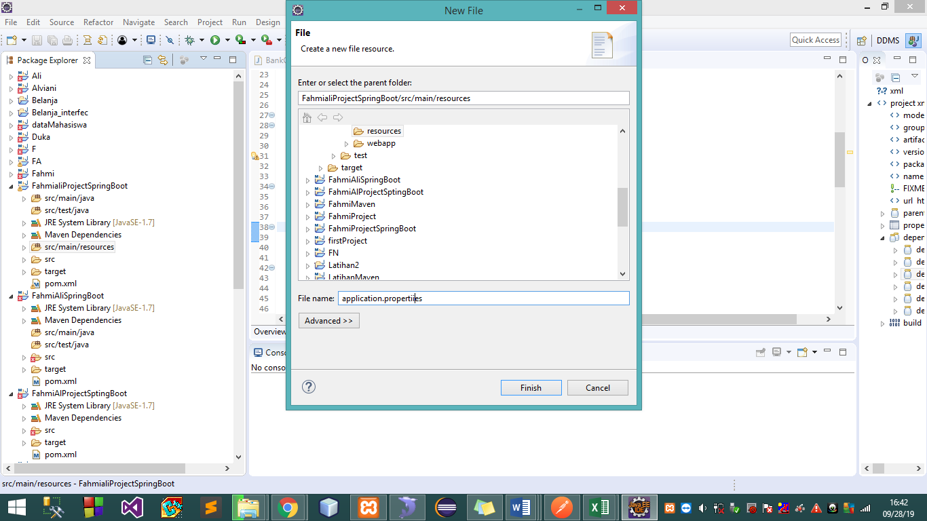

1. Give code on application properties, database name and setting port

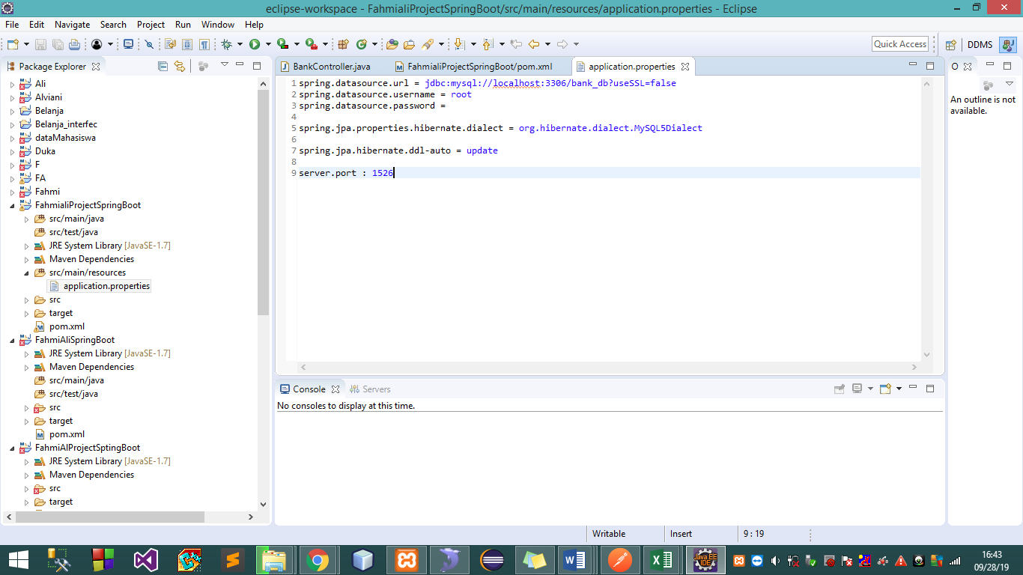

1. Right click on src/main/java choose new>package

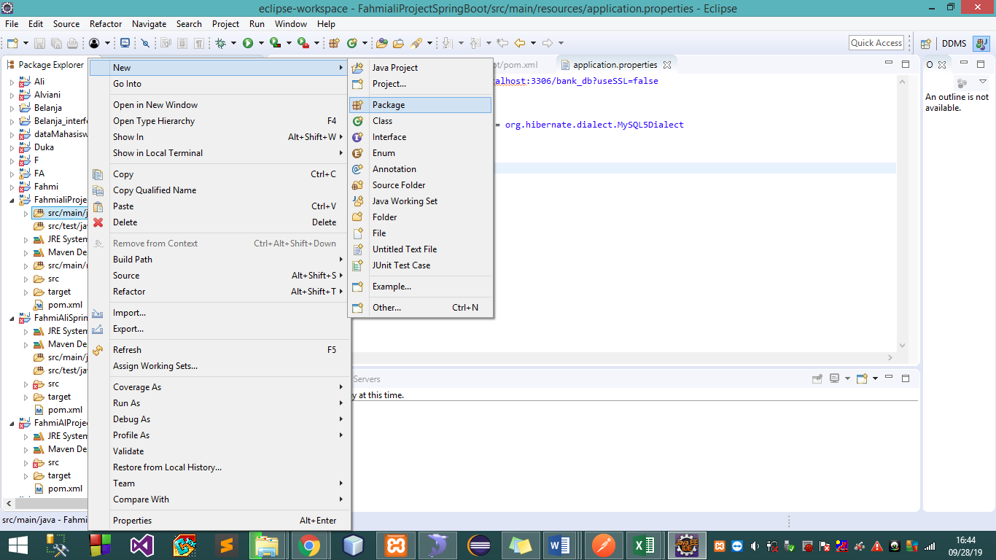

1. Create package for our need

* Controller

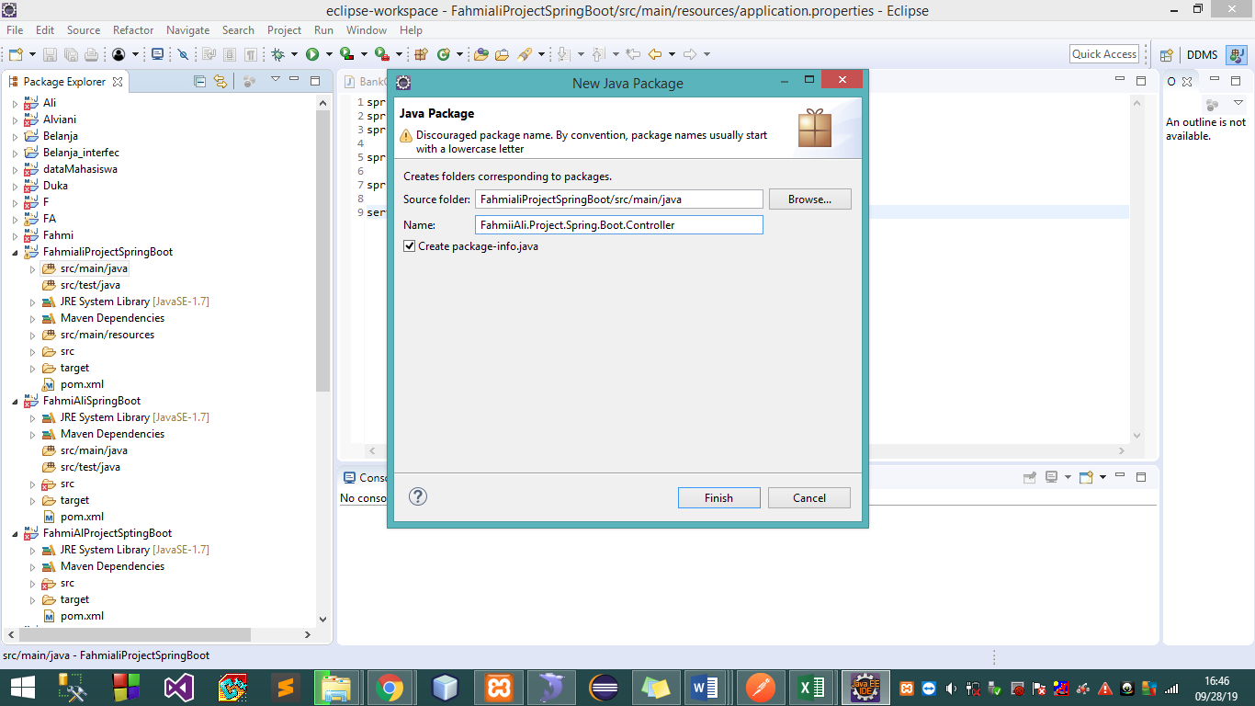

* Repository

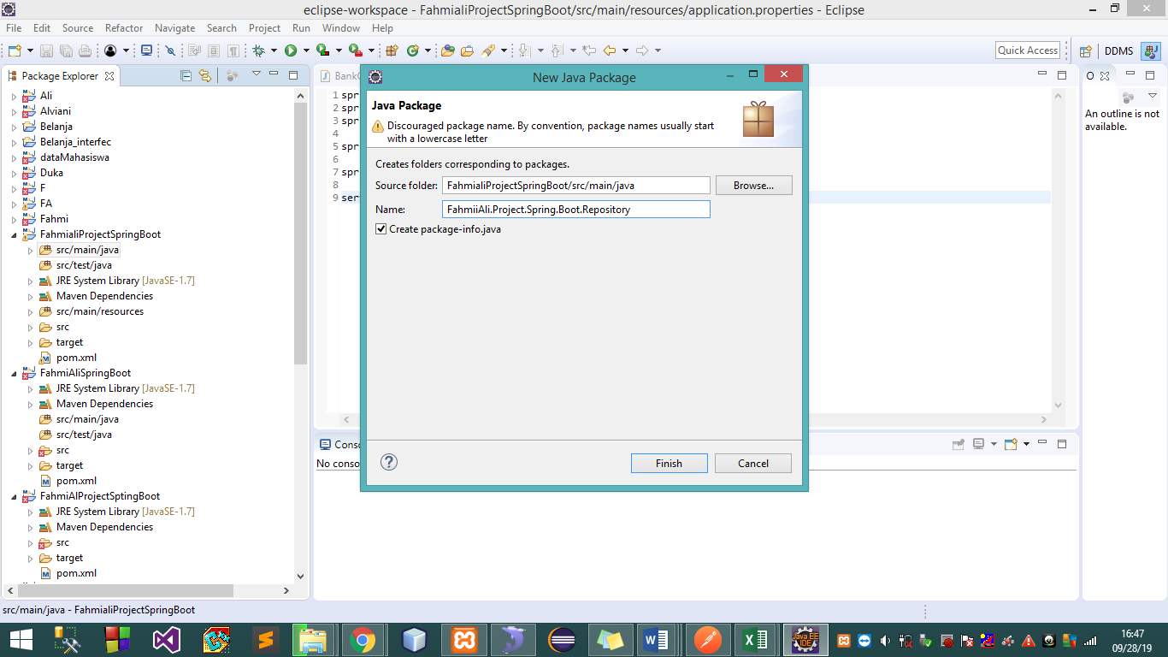

* Model

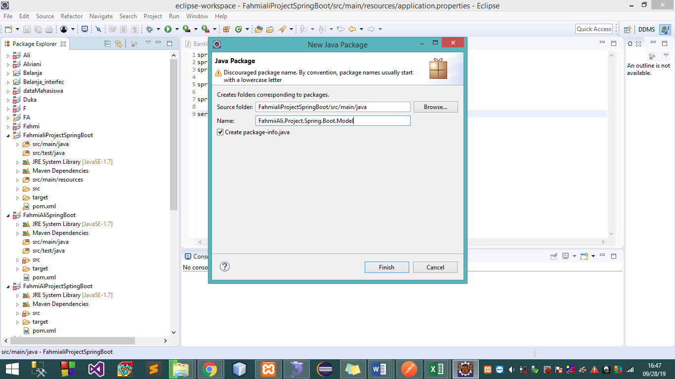

* Dao

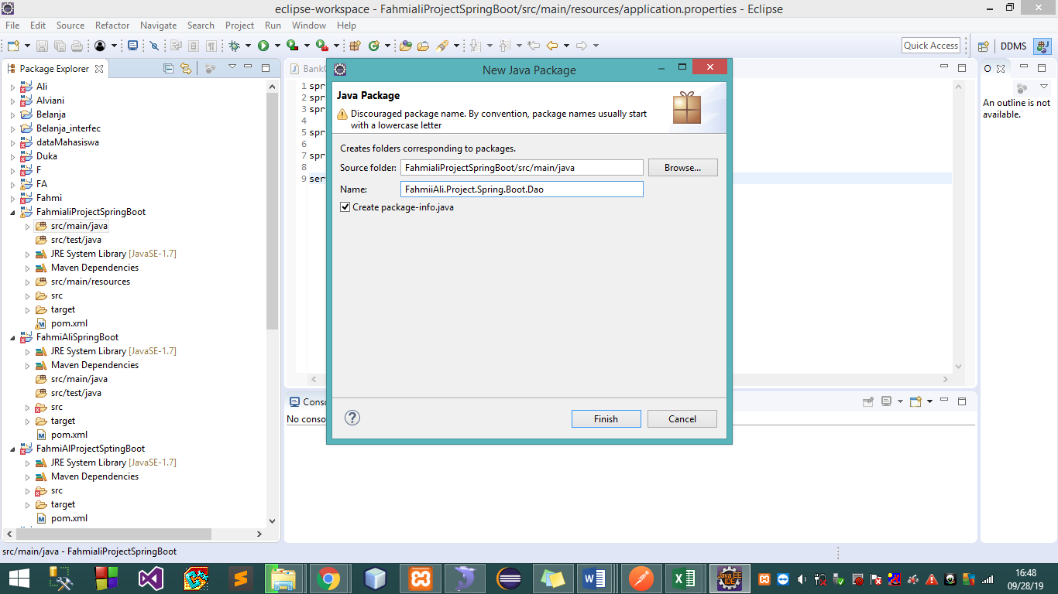

* Java application

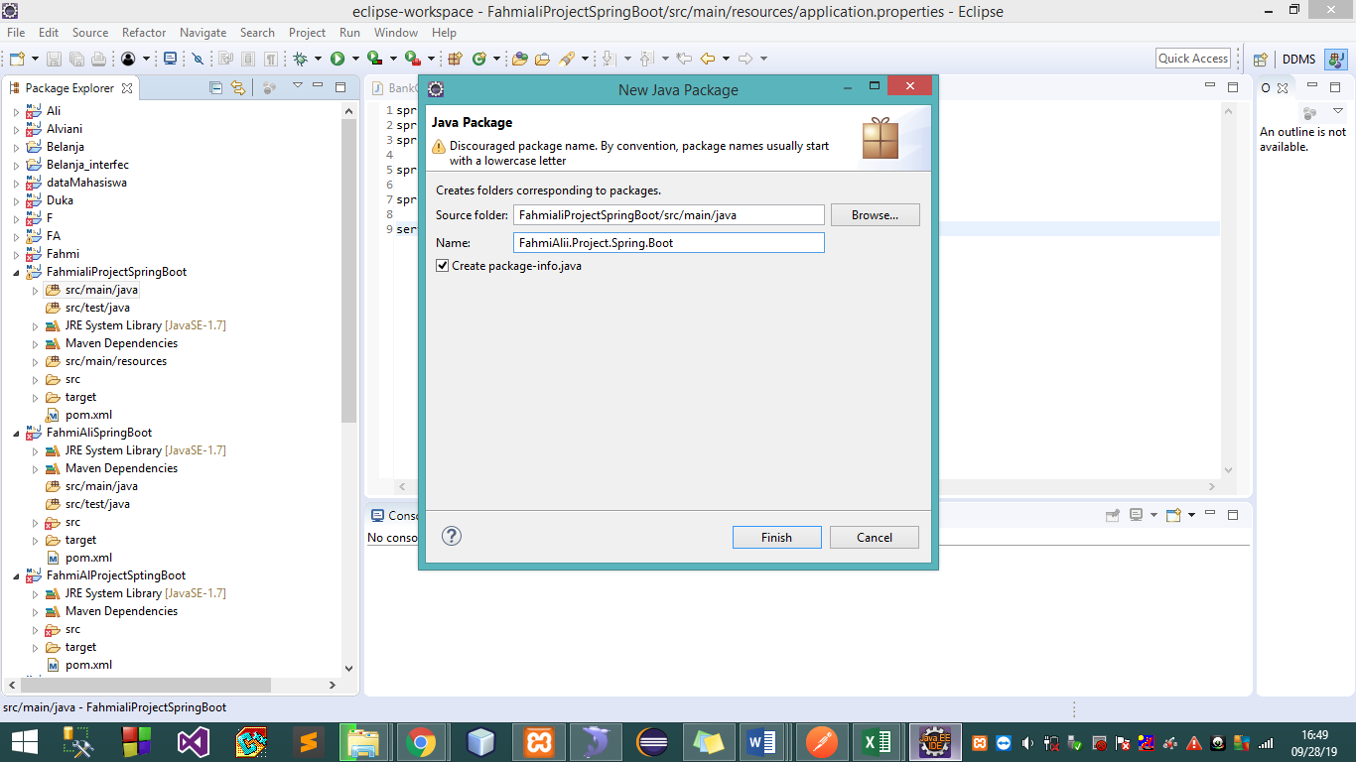

1. Let eksekusi on package repository

* Click right on package repository new>class>interface then give name

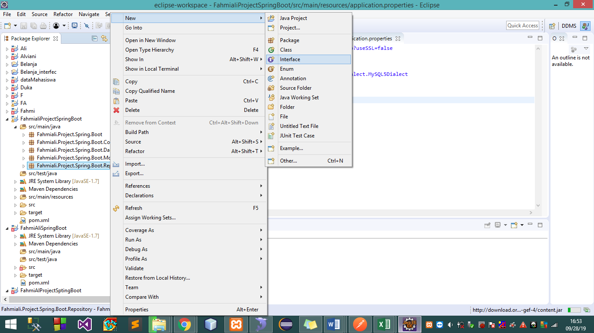

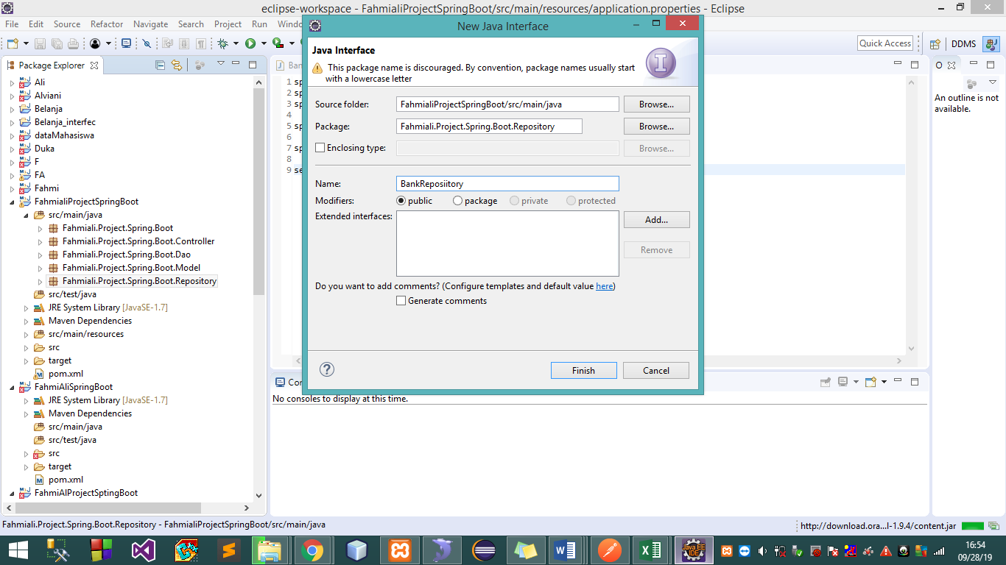

* Add extend and add query native

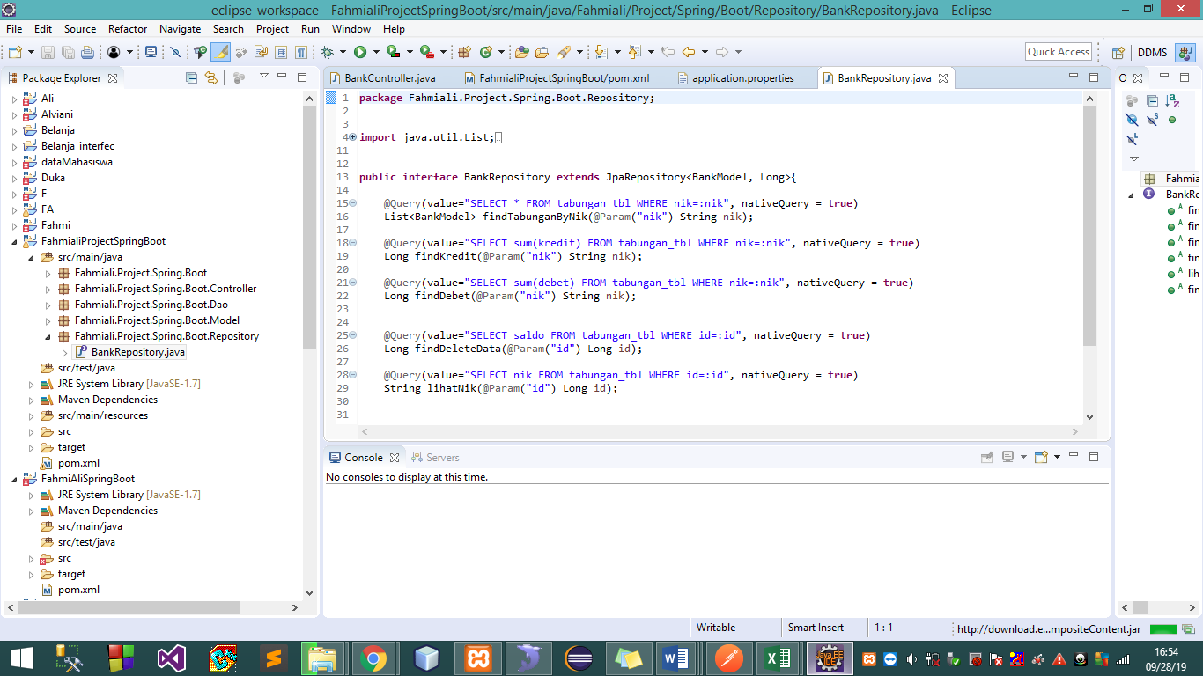

1. Let eksekusi model

* Click right on package model, new>class

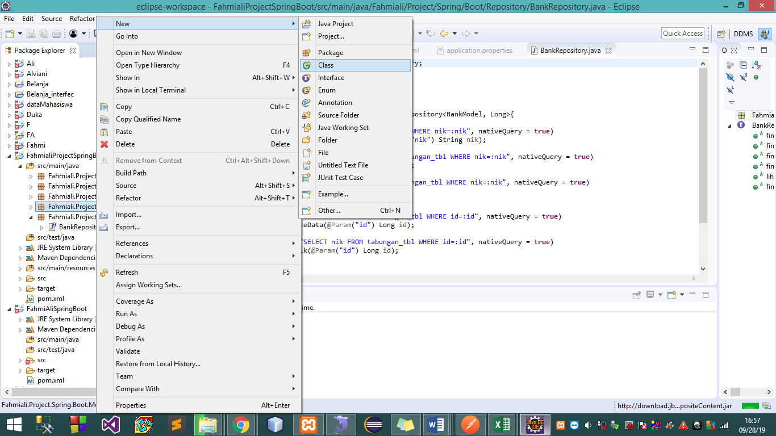

* Give name

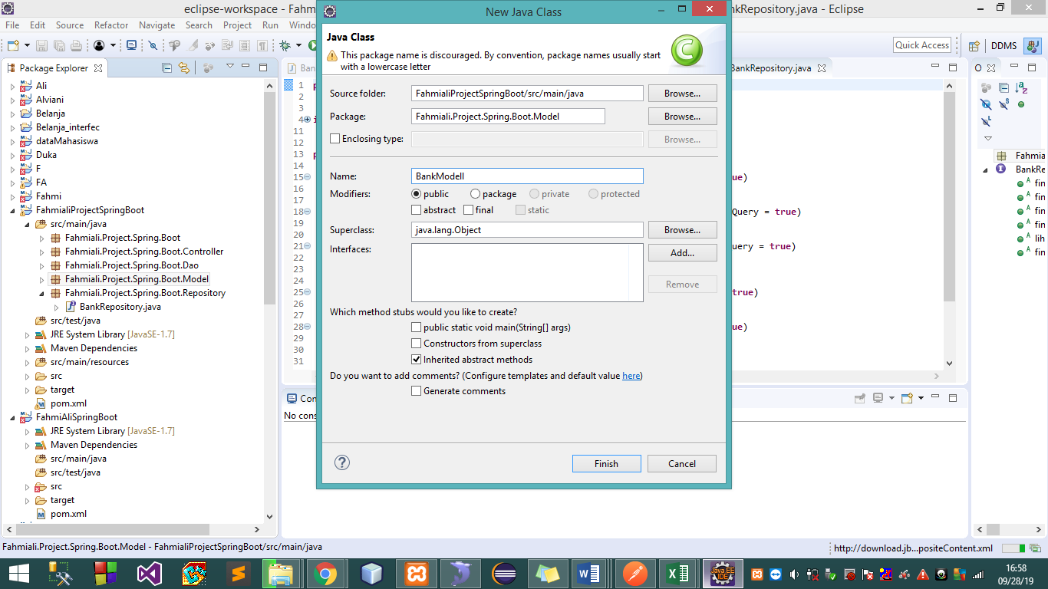

* Give code and create database

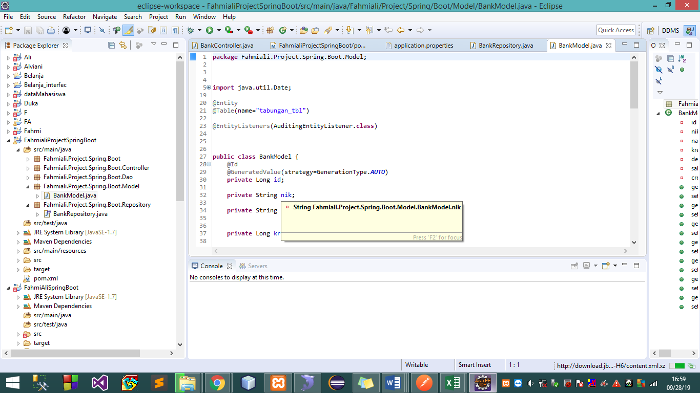

1. Let eksekusi on dao

* Click right on package model new>class

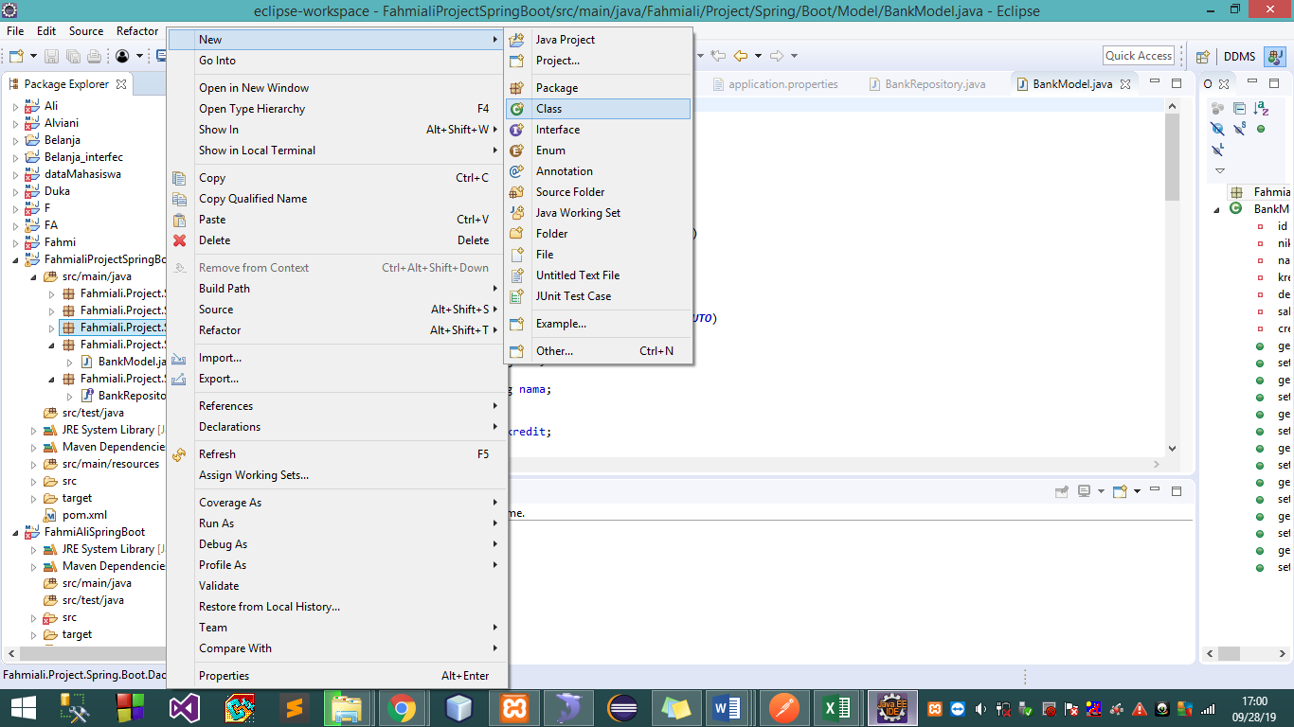

* Give name

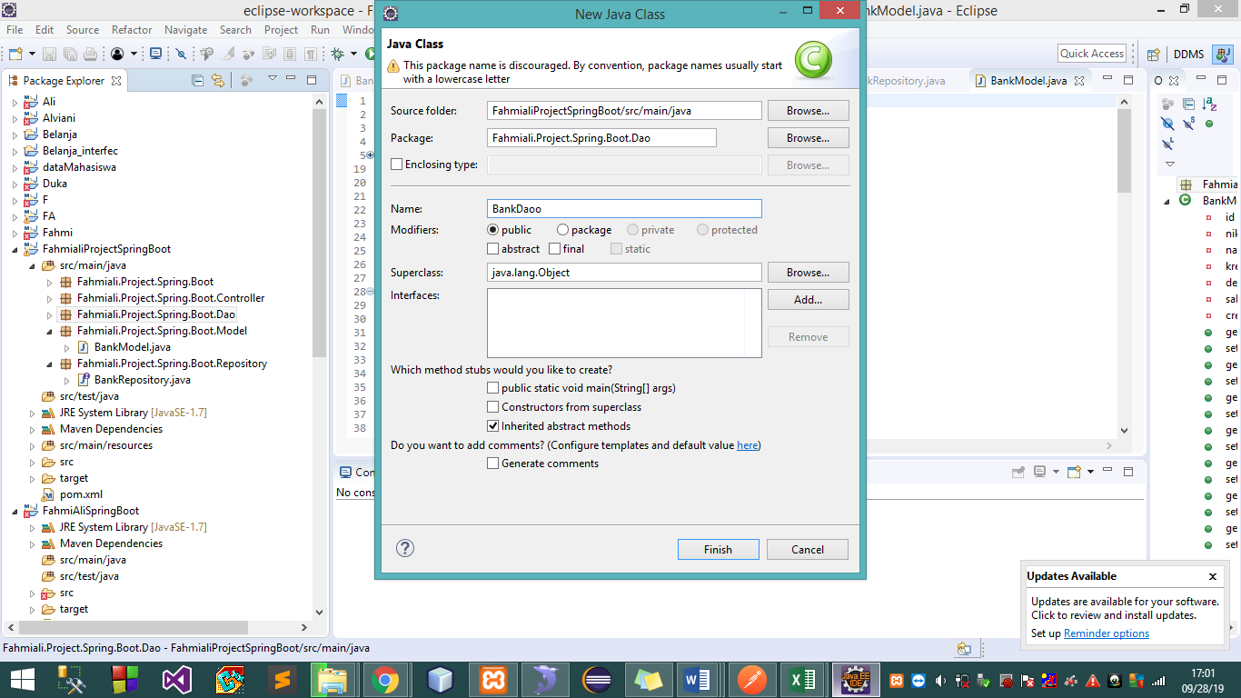

* Give code for create method

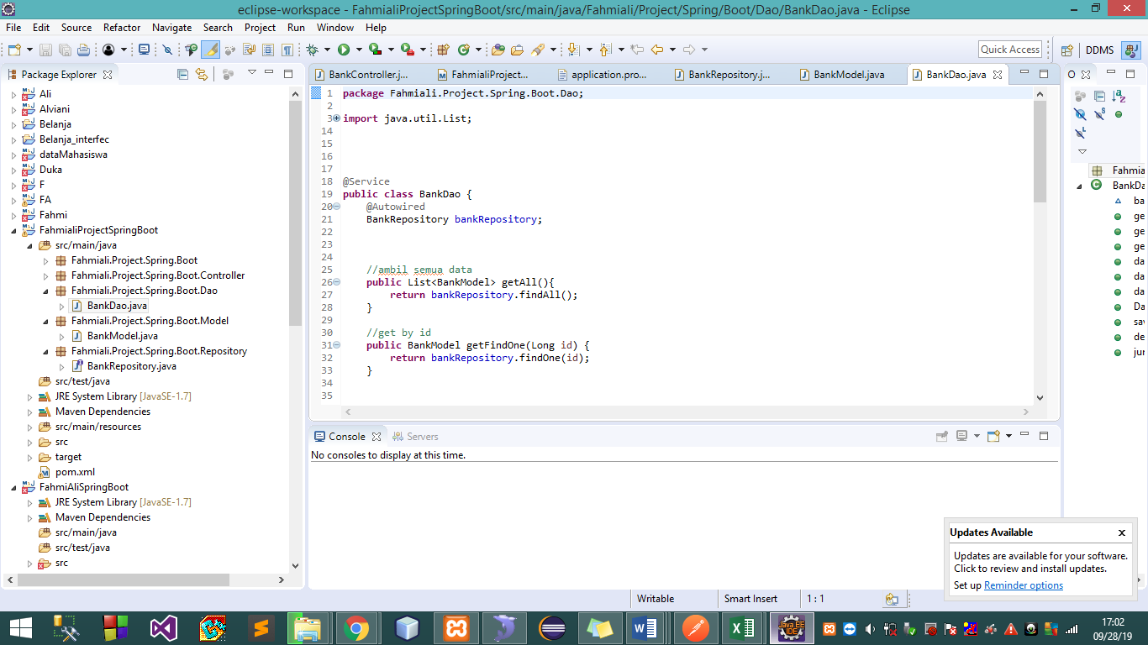

1. Let eksekusi on controller

* Click right new>class

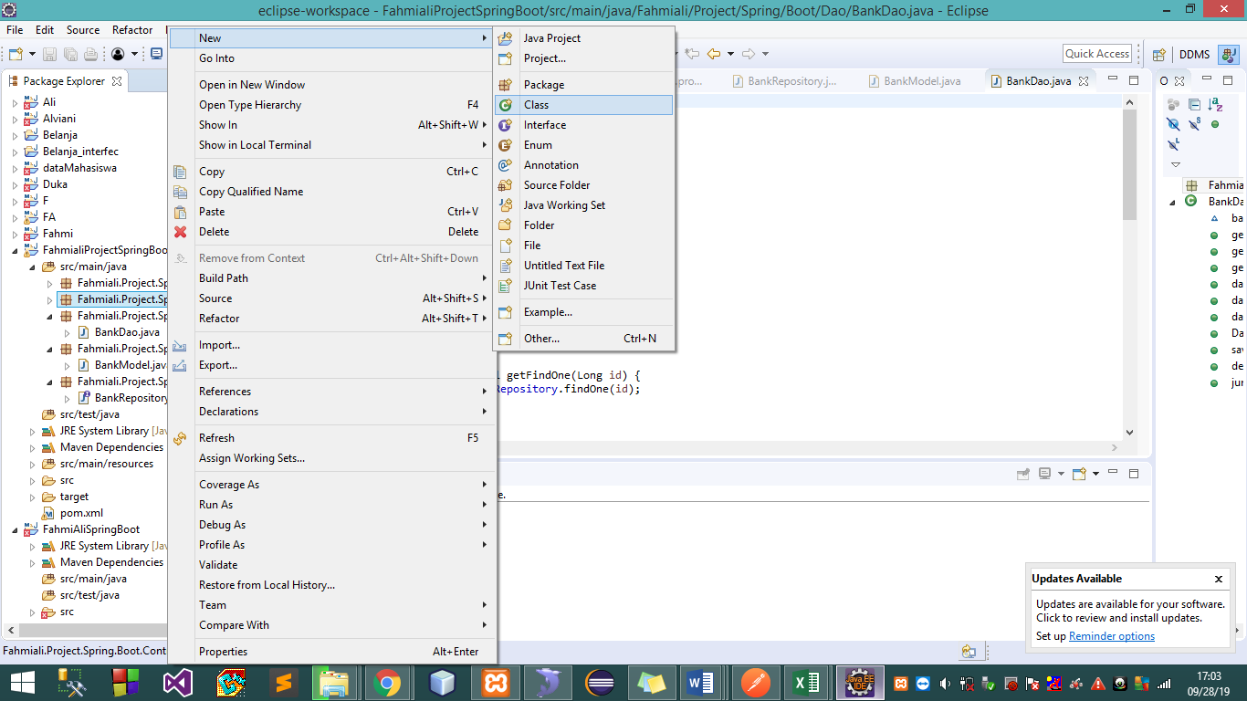

* Give name

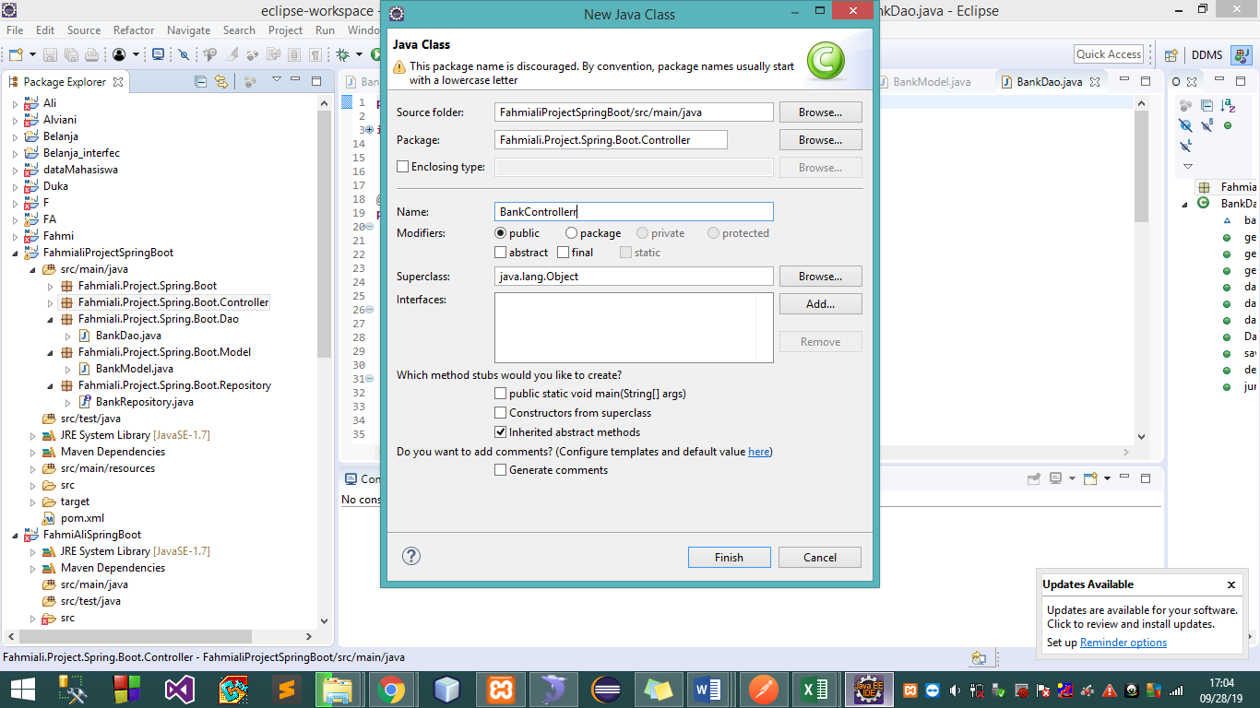

* Give code

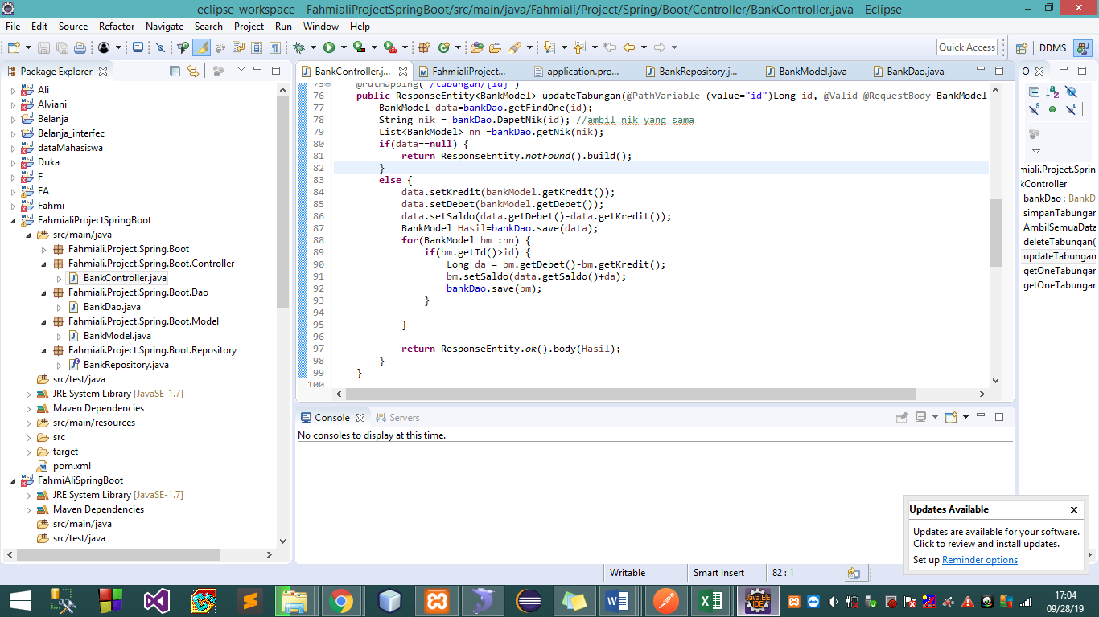

1. Let eksekusi on package class

* Click right on package class>new>class

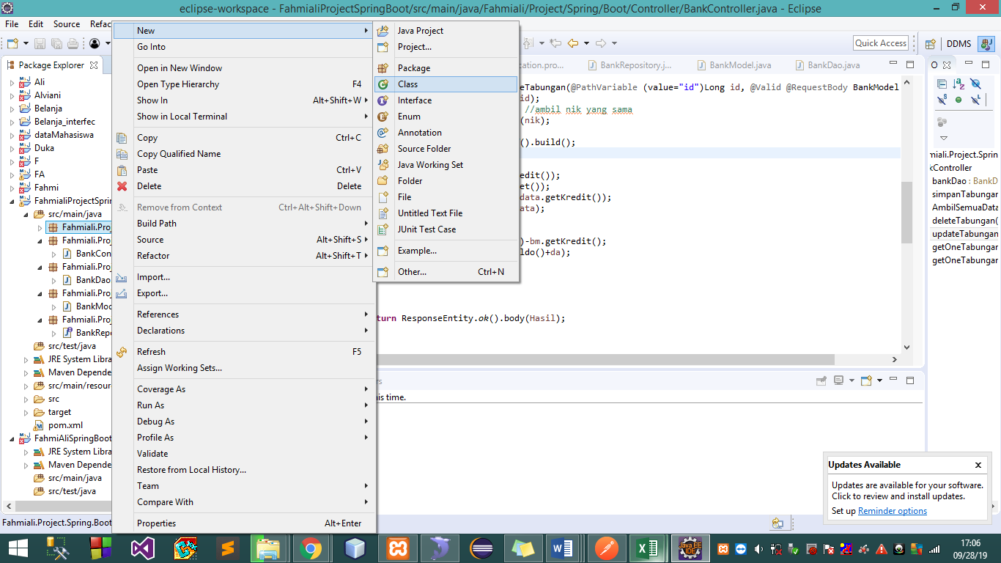

* Give name

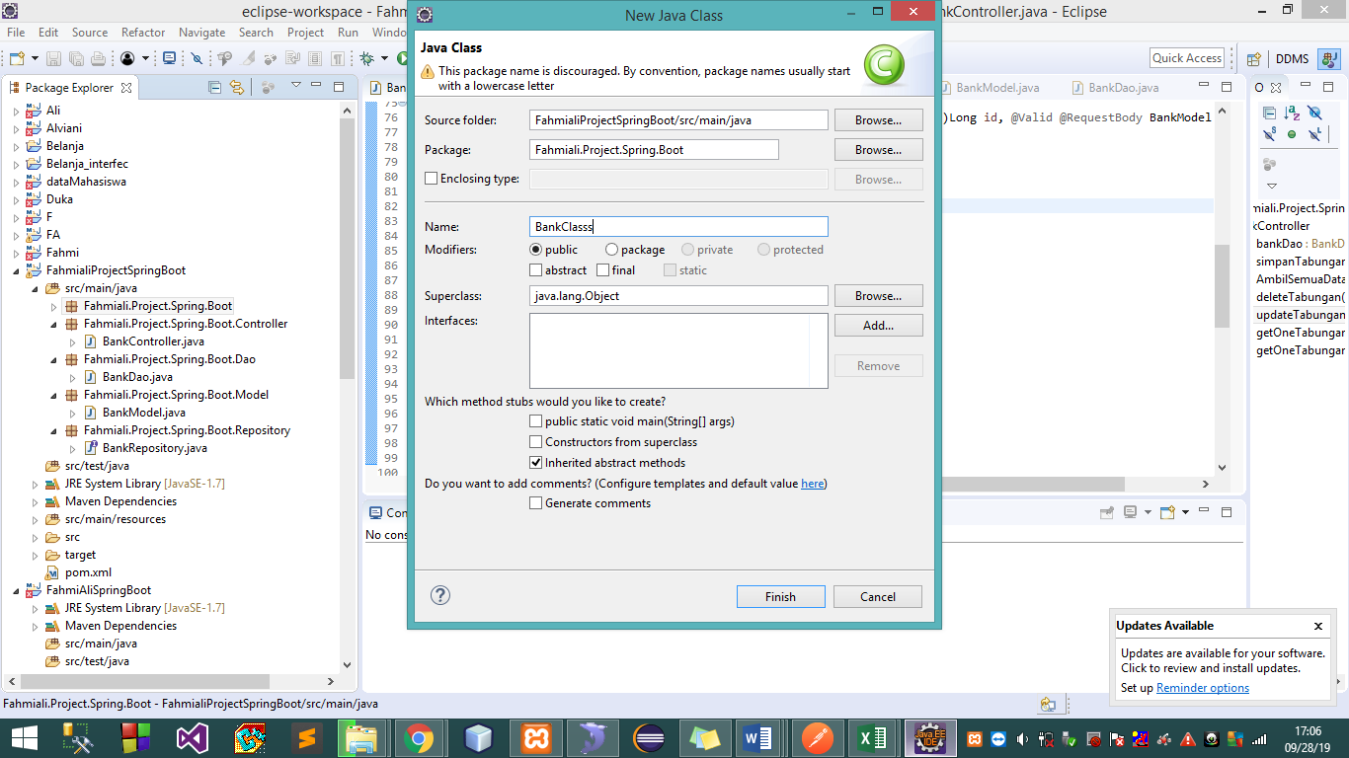

* Give code

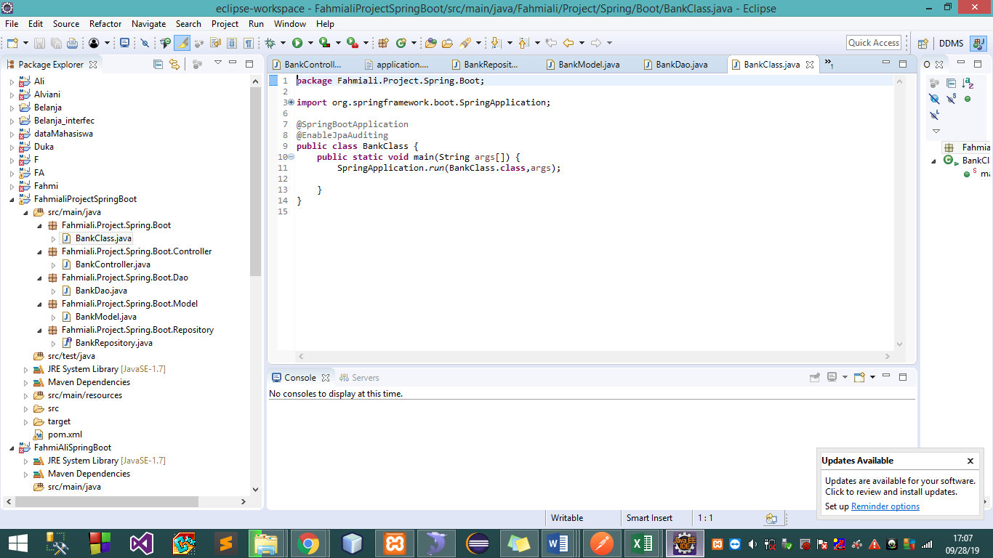

All code is finish

Don’t forget to say Alhamdulillah ☺